**EXPERIMENT NO: 3**

**Aim: Implement** **Data preprocessing using tools or languages like JAVA/ python/R**

**Import Libraries:**

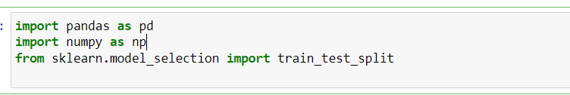

**Load the titanic dataset:**



**Display the fist few rows of the dataset:**

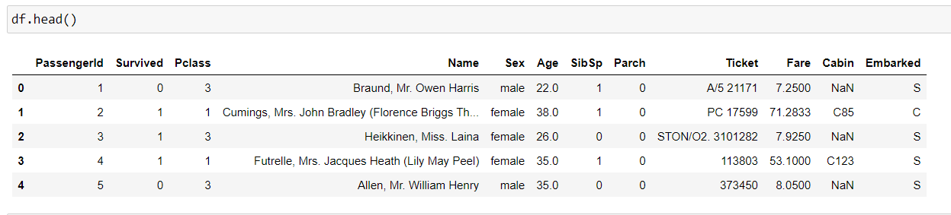

**Dropping Columns which are not usefull:**

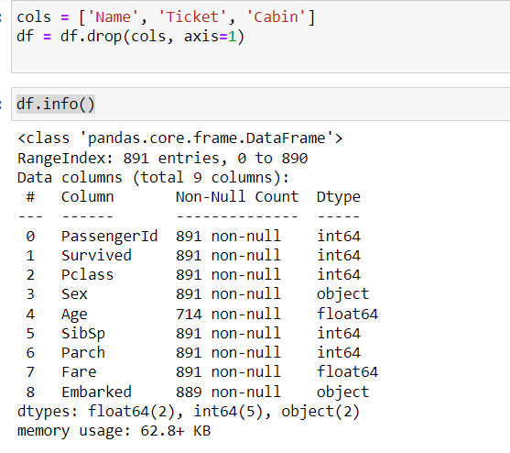

**Creating Dummy Variables:**

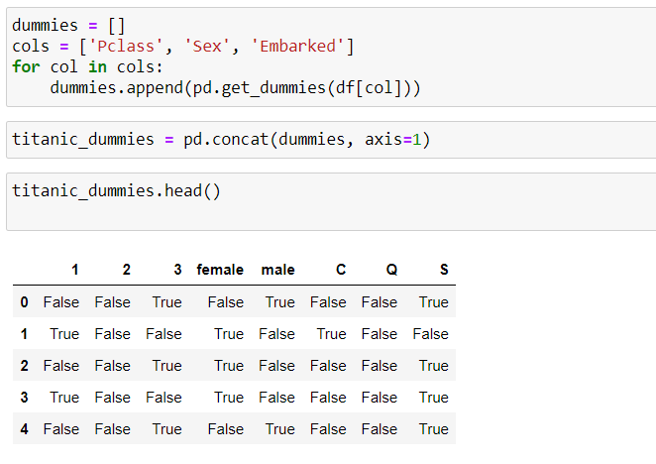

**Taking Care of Missing Data:**

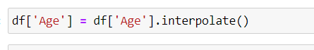

**Converting the dataframe to numpy:**

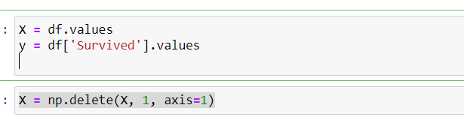

**Dividing data set into training set and test set:**

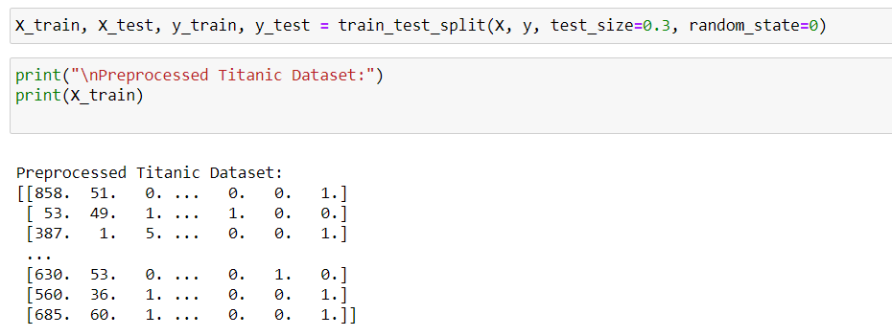

**Conclusion:**

Hence, we have successfully studied to implement Data preprocessing using tools or languages like JAVA/ python/R.